

I am in the wine field since 1988. I was in charge as Export Director at Carpenè Malvolti where I started to develop the foreign markets in the segment of Prosecco di Conegliano DOC being Carpenè Malvolti a market leader of this peculiar wine.

Results reached during the years have been excellent, since Carpenè Malvolti is now market leader on many important Countries, such as: Suisse, U.K., Canada (Québec), Japan, Hong Kong, Australia, New Zealand, Venezuela, Brasil, China.

For this reason, in 2004, I established my own Agency located in San Vendemiano – Treviso.
Of course, although I still continue my cooperation with Carpenè Malvolti, I also cooperate with some others wineries (see enclosure).

My philosophy is to manage a very attractive assortment of Italian wines that offers a best possibility of fruit success.

In order to reach this aim, I offer a complete service to a selected number of wine producers as follows:

- work the strategy for the single markets (with respect to the circumstances of the markets and the targets of the wineries)
- establish contact to potential importers / customers
- give information to the suppliers and the importers about the market situation
- support suppliers and importers in finding the right market prices
- support with information about the specific mentality / needs of the single countries
- support concerning legal specifications
- support concerning logistic solutions
- promotion ideas dedicated to each country / importer
- prepare and negotiate sales plans
- prepare and negotiate marketing plans
- all contacts and ideas usefuls for the best develop of the business cooperation
- P.R. ideas and personally support by or selected fairs/workshop/presentations.

…//…

-- 2 --

In some countries I even do have native contact persons who we could use for specific contacts to journalists or for further detailed market information.

As you can see my service offer is not just “finding customers” or “finding suppliers” but a complete and effective marketing and sales support.

I thank you for your attention and consideration and I remain at your disposal.
Please feel free to contact me any time you prefer.

Kind regards,
Lia Teo
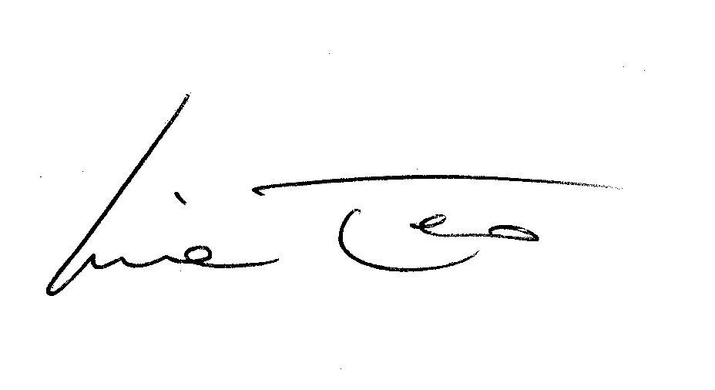

Lia Teo Italian Fine Wines
Lia Teo Italian Fine Wines - Via Liberazione 83/3 - 31020 San Vendemiano (TV) Italy
Tel: +39 0438 402604 – 405518 - Fax: + 39 0438 403024 -
e-mail: teo.lia@italianfinewines.it

